URL: www.szd.si/hazmat-2019
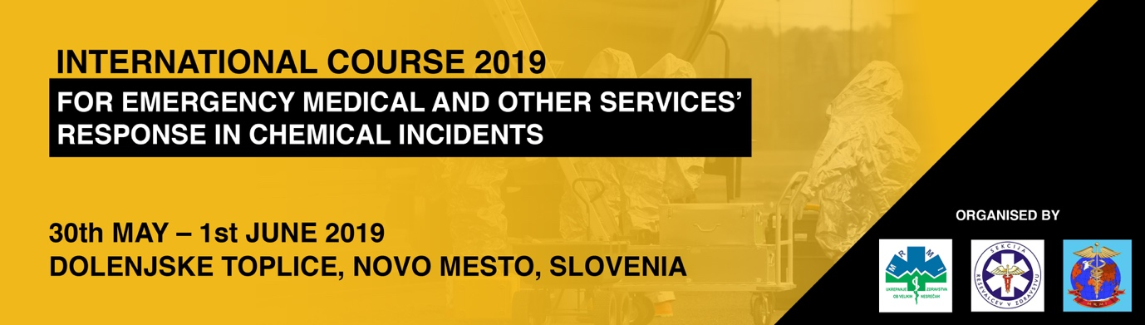

International Course for Emergency Medical and Other Services' Response in Chemical Accidents

30th May – 1st June 2019

Dolenjske Toplice, Novo mesto, Slovenia

The Slovenian Society for Medical Response to Major Incidents invites you to attend the first International Course for Emergency Medical Services' Response in Chemical Accidents that will be held between 30th May and 1st June 2019 in Novo mesto, Slovenia.

At the course, renowned international and Slovenian lecturers will present topics on the medical response to major incidents with emphasis on chemical accidents. The course covers topics such as personal protective equipment, decontamination, and triage with hands-on workshops and simulation exercises in real time.

We look forward to welcoming you to the course and in beautiful Slovenia!

Organisers

- The Slovenian Society for Medical Response to Major Incidents
- Department for EMS and Disaster Medicine of the Republic of Slovenia, Ministry of Health, Republic of Slovenia
- MRMID International

Course leaders:
Lucija Šarc
Simon Herman
Jože Prestor

Preliminary programme

Main topics:
- Special features of rescue in major chemical incidents
- Personal Protective Equipment (PPE) use in HazMat
- Decontamination of casualties – civilians
- Guidelines for health workers’ response in chemical incidents (prehospital part, hospital part, command and communication)
- Identification of hazardous substances and their hazardous properties
- Treatment of toxic trauma

For the simulation exercises, the course is divided into pre-hospital and hospital part. Participants must select the desired part at the registration. It is not possible to change the part after your registration has been confirmed. The number of attendees for the course is limited for both pre-hospital and hospital part.

Registration

To register visit: http://www.szd.si/hazmat-2019/#registration-form

Venue

Novo mesto is located in the southeastern part of Slovenia on a band of the Krka River about 70 km from the Slovenian capital Ljubljana. It is the seventh largest town in Slovenia with approximately 36,000 people living in the municipality. It is home to many successful pharmaceutical, automotive, construction, textile and other industries.

The Slovene name Novo mesto literally means ‘new town’. The city has been settled since pre-historic times and is today an important archaeological site. Many situlaes that were found here also gave the town its nickname – The Town of Situlae.

Novo mesto features a humid continental climate. Precipitation is relatively high with most rain in early summer and early autumn.

Dolenjske Toplice is a settlement a short drive away from Novo mesto. It is famous for its thermal baths that have been established in 1658. Ever since it has offered medical and wellness services to guests from all over Europe.

Important information

The course will take place in the military barracks in Novo mesto. This is a secured area with limited access and special rules that must be followed at all times. Bus transportation will be organised to and from the military barracks and Dolenjske Toplice hotels. Additional information will be provided to all attendees of the course.

Travelling

By air
Ljubljana Jože Pučnik Airport is an international airport located 24 km northwest of Ljubljana. Many airlines operate regular and charter flights to and from Ljubljana. The airport is served by an exit off the A2 motorway. Bus services and shuttles connect it with surrounding cities.

By train
Slovenske železnice operates rail passenger services in domestic, regional and international public transport. The train ride from Ljubljana to Novo mesto takes about an hour and forty minutes.

By car
Novo mesto has a good connection with the capital Ljubljana via the A2 motorway. Driving from Ljubljana to Novo mesto takes about 50 minutes. In Slovenia, a vignette (a toll sticker) is required for driving on the motorway.

Accommodation

Participants are responsible for booking their own accommodation. Course attendees will have an option to book rooms at Hotel Balnea**** and Hotel Kristal**** in Dolenjske Toplice at special room rates via email: booking@terme-krka.eu (mention that you will attend the course in your email). Accommodation will be sold on a first come, first served basis so we recommend booking as soon as your place at the course has been confirmed.

Do you need a visa?

As visa applications take time participants requiring a visa are recommended to apply well in advance. If you do require a visa for your entry to Slovenia the course organiser can issue invitation letters upon request. They can only be issued to participants that have already registered for the course. However, the course organiser cannot intervene on your behalf in case of rejection or to speed up the procedure.

Slovenia is part of the European Union and the Schengen Zone. Contact your local Slovenian embassy for more information.

Language

The official language of the course is English.

Certificate of Attendance

Certificates of attendance will be issued to all participants who successfully pass the course.

Contact

For more information about the course please contact the organizer. Email address: hazmat2019@gmail.com

